PRESS RELEASE
Monday 16 July 2012
NHS Staff celebrate Success

INSERT SUB HEADLINE

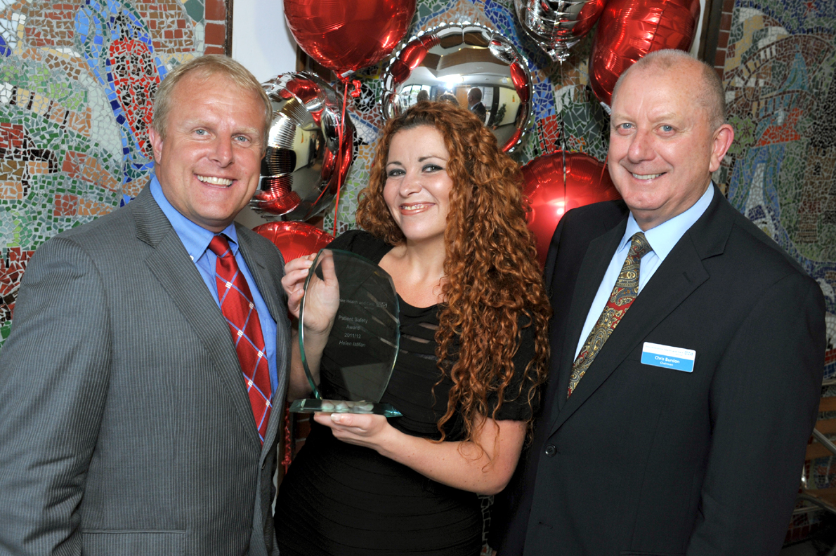

Worcestershire Health and Care NHS Trust staff have been recognised at a prestigious awards ceremony held to celebrate their achievements.

Nearly 200 staff turned up to help congratulate their colleagues at the Trust’s Staff Achievement Awards held on Tuesday 10 July at the Artix Theatre in Bromsgrove.

The ceremony, hosted by BBC Hereford and Worcester’s Breakfast Show presenter Howard Bentham, began in style with long service awards being handed to staff who have worked for the NHS for 40 years or more.

The second half of the evening was dedicated to the Staff Achievement Awards, with over 30 staff or teams shortlisted across twelve categories.

Amongst the winners was Occupational Therapist, Sue Gordon-Saner, who works at the Princess of Wales Community Hospital in Bromsgrove. Sue picked up the Patient’s Choice award, which is nominated by patients. Other winners include Mental Health Nurse, Helen Istifan, who scooped the Patient Safety Award and volunteer, Mary Bayliss, who was recognised for her voluntary work at Tenbury Community Hospital.

-cont-

-cont-

Worcestershire Health and Care NHS Trust Chairman, Chris Burdon, said:

“The staff achievement awards are a chance for us to show our appreciation to our dedicated, conscientious and loyal staff and volunteers who ensure that the people of Worcestershire have access to the best possible healthcare. We received over 200 nominations this year, from both within and outside the organisation, proving how highly our staff are regarded.

He added, “While the winners should feel immensely proud of themselves, I would like to congratulate all of our staff and volunteers who were nominated for an award. It is thanks to the hard work and dedication of all our staff that we can be so proud of the NHS in Worcestershire.”

The winners in each of the twelve categories were:
- Patient Engagement Award: Stephen Rose
- Patient Safety Award: Helen Istifan
- Innovation Award: Pregnancy Advisory Service
- Partnership Working Award: Gill Thomas
- Excellence in Integrating Services Award: Admission Prevention Team
- Apprentice of the Year: Luke Sugg
- Exemplar Employee of the Year: Rosalind Bush
- Clinical Support Award: Cherie Randle
- Volunteer of the Year: Mary Bayliss
- ‘Living the Values’ Award: Joint winners - Debbie Bradley and Claire Lees
- Patients’ Choice Award: Sue Gordon - Saner
- Business Development of the Year: Offender Health (Business Development Team)

Notes to editors

Picture caption: BBC Hereford and Worcester’s Breakfast Show presenter, Howard Bentham, Winner of the Patient Safety Award, Mental Health Nurse Helen Istifan and Worcestershire Health and Care NHS Trust Chairman, Chris Burdon.

For further information please contact:

Tom Grove, Marketing and Communications Manager, on 01905 760020 / 07501 484255 or email Tom.Grove@hacw.nhs.uk

Hardeep Cheema, Senior Marketing and Communications Officer, on 01905 733734 / 07775816420 or email Hardeep.Cheema@hacw.nhs.uk

www.hacw.nhs.uk/news.aspx

